Contents

1. Multi-Module Maven Projects 1

<dependencymanagement> Tag 1

### Multi-Module Maven Projects

1. **Structure**:
   1. 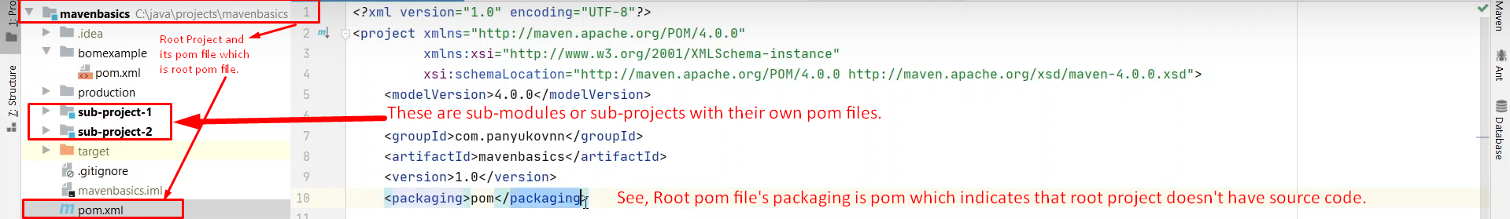
   2. The root pom.xml file is used to declare common configurations for all other sub-modules.
   3. <modules>  
      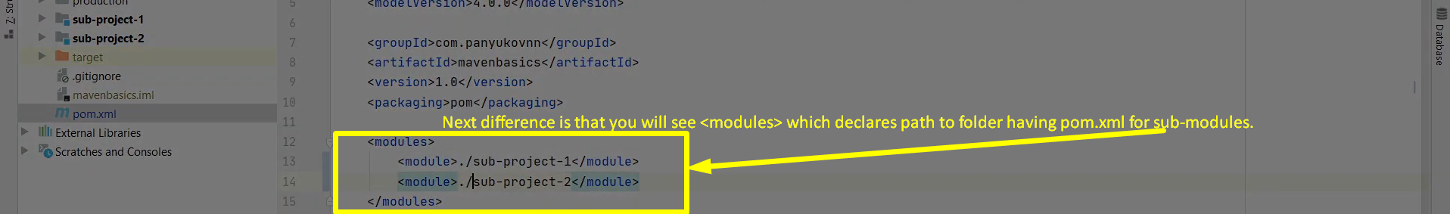
2. Sub-modules’ pom.xml files inherit the configuration from its parent pom.xml file (also called **reactor**)

### <dependencymanagement> Tag

1. **Problem**: We have some **dependencies** which are not required in all **sub-modules**.   
   So, in such case, it is not appropriate to declare those **dependencies** under **<dependencies>** in parent/root pom.xml otherwise those **dependencies** will be fetched into all **sub-modules**, and our **sub-modules** will become heavy with **executable files**.  
   Then we say ok, declare those **dependencies** in each individual **sub-module** separately wherever that **dependency** is required. But here the problem is when we need to change a version of some **dependency**, then we need to change it in each **sub-module’s pom.xml** file where that **dependency** was declared.  
   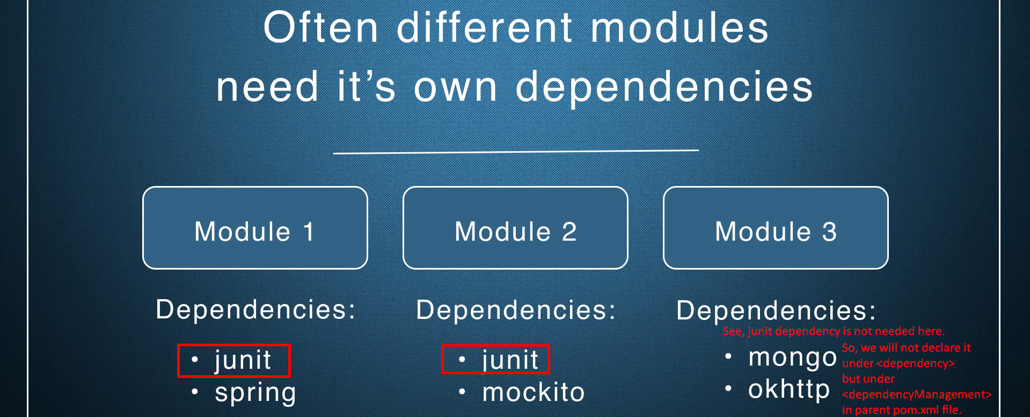
2. **Solution**: **<dependencymanagement>** Tag.  
   So, basically, this tag is used to declare common dependency configuration in **parent/reactor pom.xml** which are required by many **sub-modules** but not by all **sub-modules** with **version, scope & other configurations in reactor**.  
   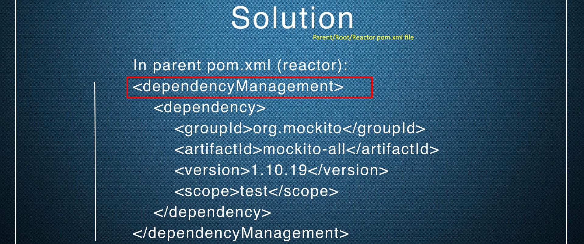  
   **NOTE**: Declared dependencies under **<dependencymanagement>** will not be fetched as dependency for the sub-modules automatically. This is actually dependency configuration managed commonly in parent pom.xml file.   
   If any sub-module need this configured dependency, that module needs to declare the dependency like this:  
   

### BOM (Bill of Materials)

1. This is another solution to <dependencymanagement>.   
   So, with BOM, you can declare the common dependency configurations (version, scope) in a special pom.xml file called BOM File.  
   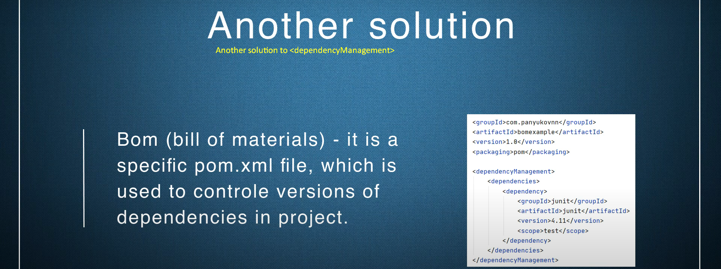  
   BOM is a special kind of pom file which is used to control version of a dependency.  
   Earlier, we were controlling dependency versions in reactor/parent/root pom file with tag <dependencymanagement> tag. But now we creating a separate file called **BOM**.
2. d

